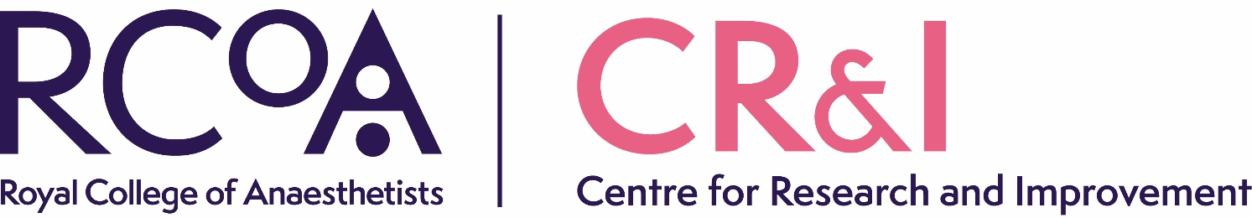
APPLICATIONS OPEN FOR RESEARCH LEADERS SCHEME
RCoA Centre for Research and Improvement (CR&I)
The RCoA Centre for Research and Improvement (CR&I) is opening the application process for its Research Leaders Scheme which provides training and mentorship for a small number of talented individuals who wish to lead their own clinical research in perioperative medicine.

Eligibility
Applicants are expected to have a proven track record of contribution to clinical research and will ideally have experience of a complete research cycle, perhaps as a grant co-applicant, through to publication and dissemination of results. Applications are welcomed from individuals of any clinical background of relevance to perioperative medicine. Applicants are encouraged to discuss the position informally before applying. To do so please contact us CRI@rcoa.ac.uk

Role
Successful recruits to the scheme will be expected to attend two in-person training meetings and other events each year at which experienced researchers will lead discussions, exchange of views and problem-based tutorials covering important practical and theoretical topics in the delivery of clinical trials and other applied research methods. They will be expected to engage actively in a range of RCoA CR&I activities, e.g. board meetings, as well as Research Leaders training events. They will also be attached to an established senior researcher who will provide mentorship and exposure to the leadership and governance of research. Candidates who have a pre-existing relationship of this type already in place can be accommodated on the scheme.

Background
The Research Leaders scheme was originally an activity of the POMCTN, which was launched in 2016 by the founding partners of the National Institute of Academic Anaesthesia (NIAA) to promote successful patient recruitment into large multi-centre clinical trials. Its aim is to identify, develop, support and coordinate the efficient delivery of large-scale clinical trials in order to improve the health outcomes of patients receiving perioperative care in the UK, promoting engagement both with the research and assists and contributes to the successful implementation of research findings.

In 2023 POMCTN became part of RCoA CR&I. The importance of a wide range of applied clinical research skills in building the case for changes in clinical practice is recognised and the scope of the Research Leaders scheme has been broadened beyond those with an interest in clinical trials to all applied clinical research methodologies. To find out more about the current members of the scheme please click here https://pomctn.org.uk/Research-Leaders

For further information please contact: CRI@rcoa.ac.uk

How to apply: For information on how to apply for this role please click here.
Closing date for applications: Friday 30 May 2025
Interview date (virtual): TBC – June 2025

