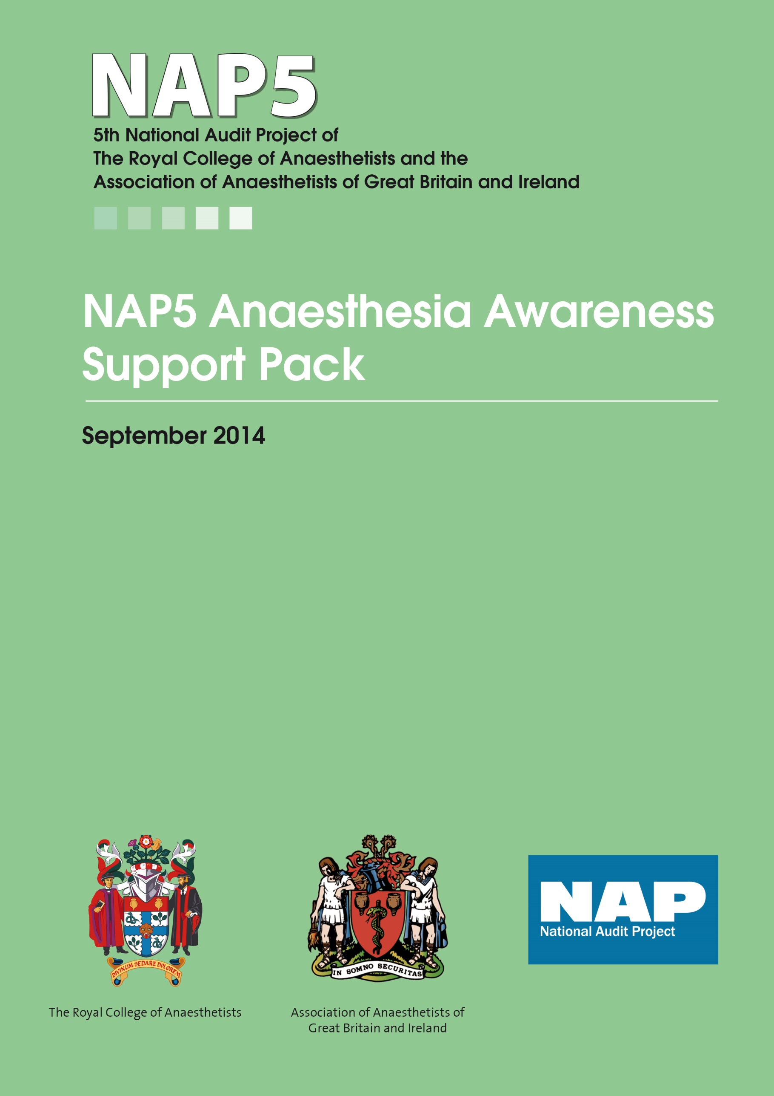
This pack is made available as part of the output of NAP5. NAP5 identified a distinct lack of policies or protocols for management of reports of Accidental Awareness during General Anaesthesia (AAGA). We hope this pathway will be useful in redressing that. The pack includes the necessary tools to analyse reports of AAGA in the same manner as was done in NAP5 and a suggested pathway of care involving anaesthetists and psychologists /psychiatrists as needed. We welcome feedback on the pathway – whether it proves useful or suggestions as to how it might be modified. The pack is provided as a word document and a pdf so it can be used as is, or modified to suit local requirements.
In the NAP5 report (see www.nationalauditprojects.org.uk/NAP5report) there is a full chapter on Patient Experiences and Psychological consequences of AAGA and this can be accessed via the same website. A summary paper was also published and is included at the end of the references below.
Tim Cook
Jaideep Pandit
Jackie Andrade
Michael Wang
September 2014

NAP5 chapter and summary papers on patient experiences and psychological consequences of AAGA
Andrade J, Wang M, Pandit JJ. Patient experiences and psychological consequences of AAGA. In Accidental Awareness during General Anaesthesia in the United Kingdom and Ireland: Report and Findings. Editors Pandit JJ, Cook TM. The Royal College of Anaesthetists, London ISBN 978-1-900936-11-8.
Cook TM, Andrade J, Bogod DG, et al. The 5th National Audit Project (NAP5) on accidental awareness during general anaesthesia: patient experiences, human factors, sedation, consent and medicolegal issues. Anaesthesia 2014;69:1102-16.
doi: 10.1111/anae.12827.
Cook TM, Andrade J, Bogod DG, et al. The 5th National Audit Project (NAP5) on accidental awareness during general anaesthesia: patient experiences, human factors, sedation, consent and medicolegal issues. British Journal of Anaesthesia 2014;113:560-74.
doi: aeu314.

This pathway is created on the assumption that psychological trauma of AAGA is compounded by lack of or insensitive post-operative management. This can compound the long-term severity of psychiatric consequences which, if untreated, become progressively more difficult to ameliorate. Early identification, monitoring and psychological intervention (where necessary) of AAGA are known to be likely to reduce psychological morbidity and costs.
NAP5 revealed many cases of AAGA where patients were minimally distressed with little need for psychological support; typically where simple support had been offered promptly. This is a basis for the meeting stage of our Psychological Pathway, emphasising the value of empathetic communication. The second stage, analysis, seeks to identify causes of AAGA to inform continuing dialogue and prevent recurrence. The third stage, support, stems from evidence that psychological sequelae of AAGA, including memories, increase in the weeks following anaesthesia and are amenable to treatment (NICE PTSD Guidelines).

NAP5 Awareness Support Pathway for AAGA
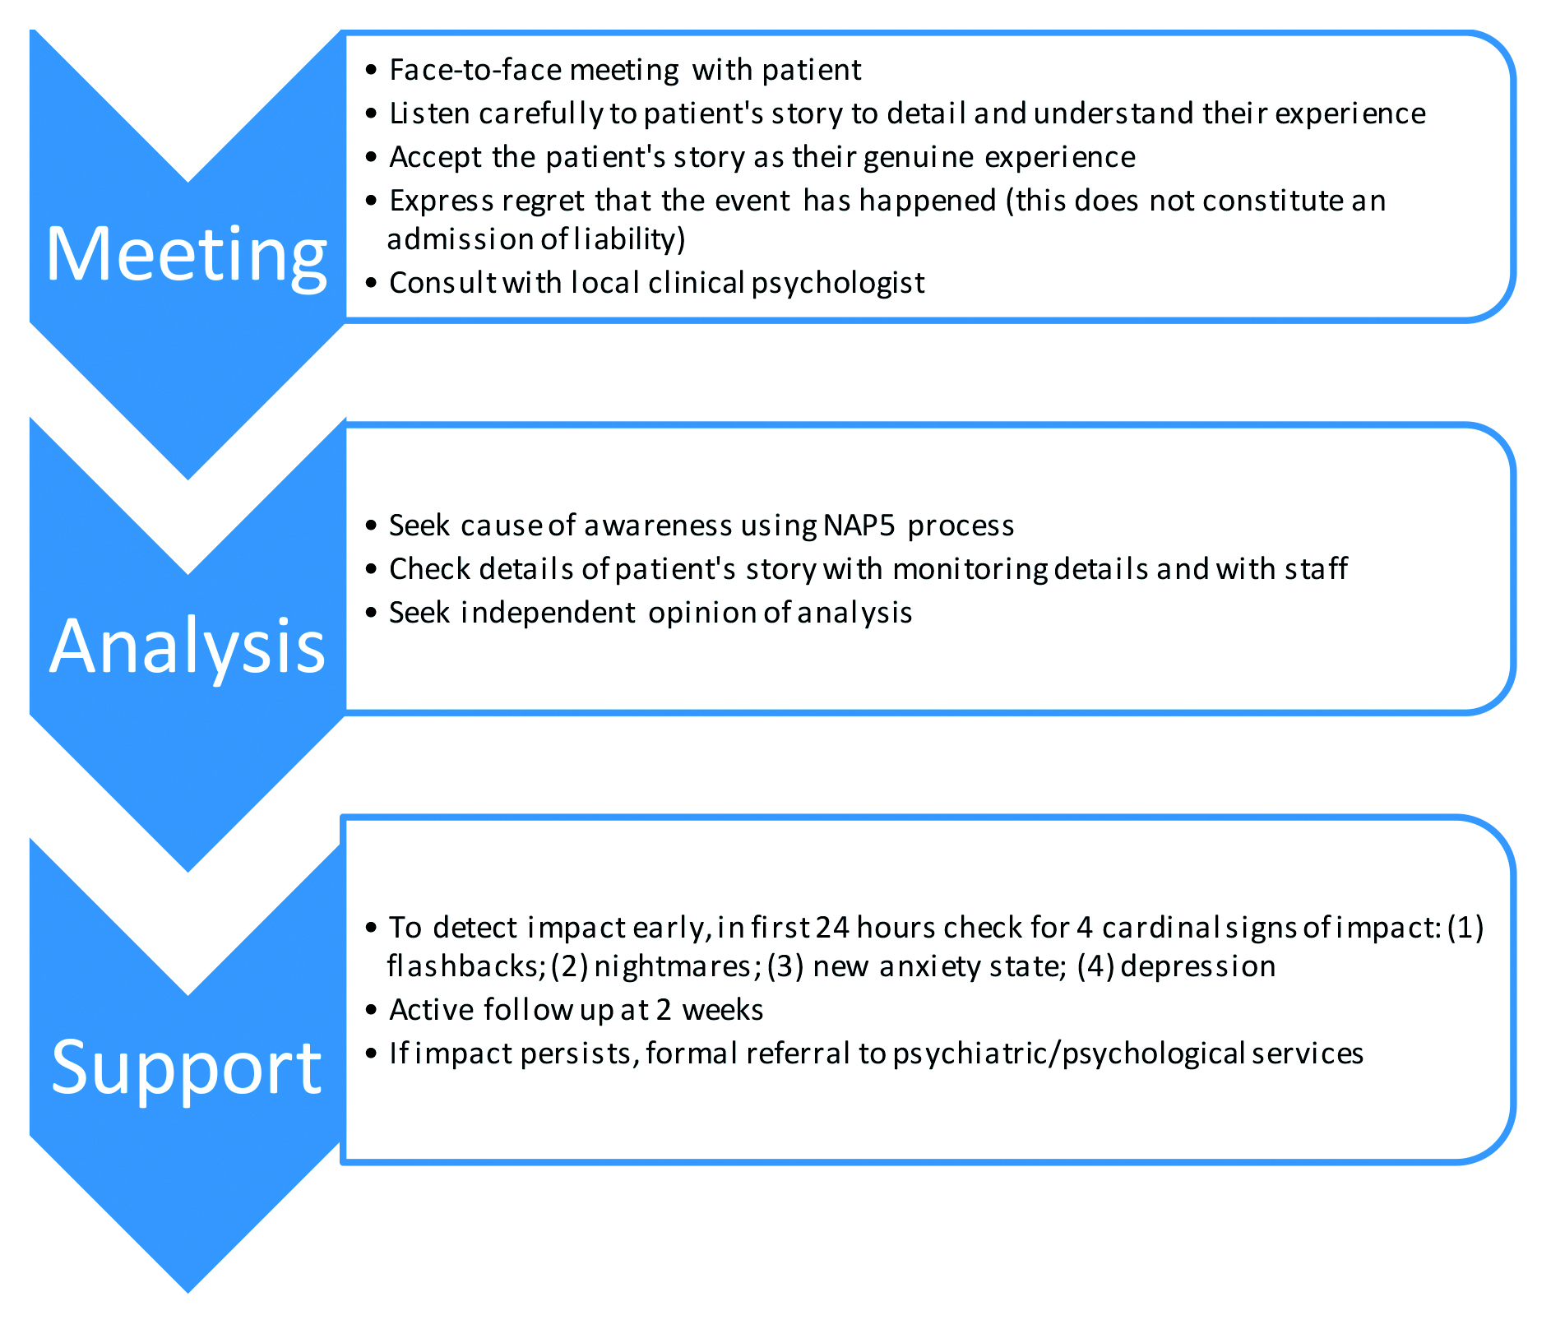

STAGE 1: MEETING STAGE
Face meeting with patient. Ideally this should include the anaesthetist who provided the anaesthesia care and where this is a trainee, a suitably senior colleague. Where this is not possible or desirable a senior colleague should take their place.
Listen to patient story and experience. Blatant fabrication by the patient is extremely rare; however, careful note should be taken of all details provided by the patient. Particular attention should be devoted to the type of experience (eg, from auditory sensations only to touch, or pain and/or paralysis). This enables classification according to the Michigan scale (Table 1). An attempt should also be made to classify the patient’s situation according to the modified NPSA score (Table 2) as a measure of severity of medium to long-term impact. Careful account of information that could be corroborated, or refuted, is very important to establish the veracity of the report.
Table 1 Michigan Awareness Classification Instrument to describe patient experience during AAGA
Class 0 | No accidental awareness during general anaesthesia
Class 1 | Isolated auditory perceptions
Class 2 | Tactile perceptions (with or without auditory)
Class 3 | Pain (with or without tactile or auditory)
Class 4 | Paralysis (with or without tactile or auditory)
Class 5 | Paralysis and pain (with or without tactile or auditory)

Add an additional designation of D if there was distress during the experience.

Source: Mashour GA et al. A novel classification instrument for intraoperative awareness events. Anesth Analg 2010;110:813–5.

Table 2 Modified NPSA classification of patient harm after AAGA
SEVERITY | Revised definitions for NAP5
None 0 | No harm occurred
Low 1 | Resolved or likely to resolve with no or minimal professional intervention. No consequences for daily living, minimal or no continuing anxiety about future healthcare.
Moderate 2 | Moderate anxiety about future anaesthesia or related healthcare. Symptoms may have some impact on daily living. Patient has sought or would likely benefit from professional intervention.
Severe 3 | Striking or long-term psychological effects that have required or might benefit from professional intervention or treatment: severe anxiety about future healthcare and/or impact on daily living. Recurrent nightmares or adverse thoughts or ideations about events. This may also result in formal complaint or legal action.
Death 4 | Caused death
Original NPSA classification www.nrls.npsa.nhs.uk/resources/collections/seven-steps-to-patientsafety/? entryid45=59787

Accept the patient’s story as their genuine experience. This means listening carefully and empathically to the patient’s account, without interruption or contradiction (even if there are inconsistencies) and taking verbatim notes of the patient’s account.
Express regret. This can be done using words like “I am sorry to hear of your experience; we need to establish what has happened”. This is not an admission of error or medicolegal culpability.
Consult with local clinical psychologist. Early involvement may be of value where there is evidence of distress or severe trauma responses.

STAGE 2: ANALYSIS
Seek cause of awareness using NAP5 process. In addition to establishing the Michigan and modified NPSA score, this involves classifying the report as certain or probable (Class A); possible (Class B); a case where sedation was intended (Class C); a case in the ICU (Class D); unassessable (Class E); unlikely AAGA (Class F) or unintentional paralysis due to drug error (Class G). A Class H may be used for cases not fitting any of these classifications (Table 3).
Table 3 Classification into types of report
All classes are mutually exclusive: a patient report can only be classified into one group.

SEVERITY | Definitions for NAP5
A. Certain/ probable AAGA | A report of AAGA in a ‘surgical setting’ in which the detail of the patient story is judged consistent with AAGA, especially where supported by case notes or where report detail is verified.
B. Possible AAGA | A report of AAGA in a ‘surgical setting’ in which details are judged to be consistent with AAGA or the circumstances might have reasonably led to AAGA, but otherwise the report lacks a degree of verifiability or detail. Where uncertain whether a report described AAGA the case should be classified as possible rather than excluded.
C. Sedation | A report of AAGA where the intended level of consciousness was sedation.
D. ICU | A report of AAGA from a patient in, or under the care of the intensive care unit, who underwent a specific procedure during which general anaesthesia was intended.
E. Unassessable | A report, where there was simply too little detail submitted to make any classification possible.
F. Unlikely | Details of the patient story are deemed unlikely, or judged to have occurred outside of the period of anaesthesia or sedation.
G. Drug error | Syringe swaps and drug errors leading to brief awake paralysis.
SO Statement only | A patient statement describing AAGA, but there were no case notes available to verify, refute or examine that claim further.

Check details of patient’s story. For cases that are certain/probable or possible (Class A/B) causality can be determined by careful analysis of the anaesthetic chart and anaesthetist’s report. Note, as confirmed by NAP5, that some cases have no apparent cause and may be due to insensitivity to anaesthetic drugs. As NAP5 and others have shown, patients may be mistaken in several ways. They may not have had a general anaesthetic at all; or may have experienced an unpleasant dream not involving specific surgical events. Events during the immediate post-operative or pre-operative period may be incorrectly attributed as intra-operative. Therefore proper analysis is important and any such confusion should be addressed gently, with care and understanding.
Table 4 Evidence
High quality: Where the report of AAGA is, or could easily be, confirmed by other evidence.
Circumstantial: Where the report of AAGA is supported only by clinical suspicion or circumstance.
Plausible: Where other evidence was available, but this does not shed further light on the matter.
Unconfirmed: Cases where there was no evidence other than the patient report.
Implausible: Where there is no evidence other than the patient story and where this is judged implausible.
Seek independent opinion. The Analysis process may be undertaken by a small group with appropriate skills and knowledge (independent of the hospital if necessary), who can provide an unbiased opinion as to the classification, impact and likely causality, in much the same way as NAP5 has done.

STAGE 3: SUPPORT
Detect impact early. Inpatient review or follow up telephone consultation for day cases is essential within 24 hours to establish if there are flashbacks, nightmares, any new anxiety state or symptoms of depression. If early symptoms are concerning early referral to an appropriate psychologist or psychiatrist is advised.
Two week review. The same follow up should be conducted at 2 weeks. Even where true AAGA is unlikely, NAP5 has shown that the patient interpretation is of such importance that the impact of peri-operative unpleasant experiences may be severe and psychological support is still needed.
Support for impact. If impact persists, a formal psychological review is needed. Once referral to a psychologist or psychiatrist is found necessary, in accordance with NICE Guidance, PTSD-type reactions should be treated with either trauma-focussed Cognitive Behavioural Therapy or Eye-Movement Desensitisation and Reprocessing. If there are none of the four cardinal signs of impact, (flashbacks, nightmares, a new anxiety state or symptoms of depression) then the patient can be encouraged to make contact if they have later concerns.

Supporting references to this Pathway
Bruchas et al. Anesthesia awareness: narrative review of psychological sequelae, treatment, and incidence. Journal of Clinical Psychology in Medical Settings 2011;18:257–67.
NICE. Post-traumatic stress disorder (PTSD): The management of PTSD in adults and children in primary and secondary care. 2005. (www.nice.org.uk/cg26).
Phelan J, et al. Long-term posttraumatic effects of intraoperative awareness in children. Paediatric Anaesthesia 2009;19:1152–56.
Schwender D, et al. Conscious awareness during general anaesthesia: patients’ perceptions, emotions, cognition and reactions. British Journal of Anaesthesia 1998;80:133–39.
Wang, M. The psychological consequences of explicit and implicit memories of events during surgery. In Ghoneim, M. (ed.) Awareness during Anesthesia, Woburn USA: Butterworth-Heinemann, 2001.

NAP5 AAGA SUPPORT PACK OUTPUT
Step 1 Meeting

Patient ………………………………………………………………… | Supporter ………………………………………………………..
Date ……………………………………………………………………. | Time ………………………………………………………………..
Anaesthetist 1 …………………………………………………….. | Anaesthetist 2 …………………………………………………
Other ……………………………………………………………………

Brief description of report

Patient experience
Michigan class |  | Modified NPSA Class

Initial consequences for patient

Explanation to patient

Apology to patient? Yes/No
By whom …………………………...................
Datix form completed? Yes/No
Referred to clinical psychologist/psychiatrist early? Yes/No
Entered in awareness registry? Yes/No
Date for review ………………………….........
Person to review ………………………….......

Step 2 Analysis
Patient …………………………………………………………………. | Supporter ………………………………………………………
Date …………………………………………………………………….. | Time ………………………………………………………………
Anaesthetist 1 ……………………………………………………… | Anaesthetist 2 ……………………………………………….
Type of Report (NAP5 class) |  | Grade of evidence (NAP5 grade)

Brief description of analysis

Table 5 Contributory, causal and mitigating factors
Contributory factors | Contributory | Causal | Mitigating
Communication (includes verbal, written and non-verbal: between individuals, teams and/or organisations)
Education and Training (e.g. availability of training)
Equipment/ resource factors (e.g. clear machine displays, poor working order, size, placement, ease of use)
Medication (where one or more drugs directly contributed to the incident)
Organisation and strategic (e.g. organisational structure, contractor/agency use, culture)
Patient (e.g. clinical condition social/physical/psychological factors, relationships)
Task (includes work guidelines/procedures/policies,
availability of decision making aids)
Work and environment (e.g. poor/excess administration, physical environment, work load and hours of work, time pressures)
Other
Unknown
Source: NPSA classification www.nrls.npsa.nhs.uk/resources/collections/seven-steps-to-patientsafety/?entryid45=59787

Preventability (how it might have been prevented) Yes/No/Uncertain

Lesson learnt

Departmental actions

Individual actions

Step 3 Support
Patient …………………………………………………………………… | Supporter ………………………………………………………..
Date ………………………………………………………………………. | Time ……………………………………………………………….
Anaesthetist 1 ……………………………………………………….. | Anaesthetist 2 …………………………………………………
Other ……………………………………………………………………..

Inpatient review or follow up telephone consultation for day cases is essential within 24 hours
 | 24 hours | 1 week | 2 weeks
Flashbacks
Education and Training (e.g. availability of training)
Nightmares
New anxiety state
Symptoms of depression
Other

Comment and actions

Referred to clinical psychologist/psychiatrist Yes/No
Who …………………………………………
When ……………………………………….

Further actions

