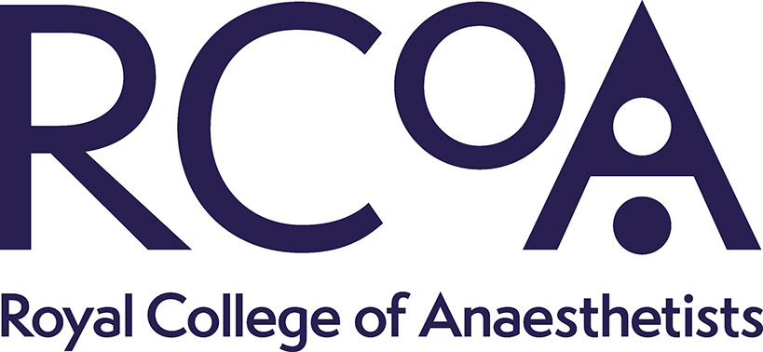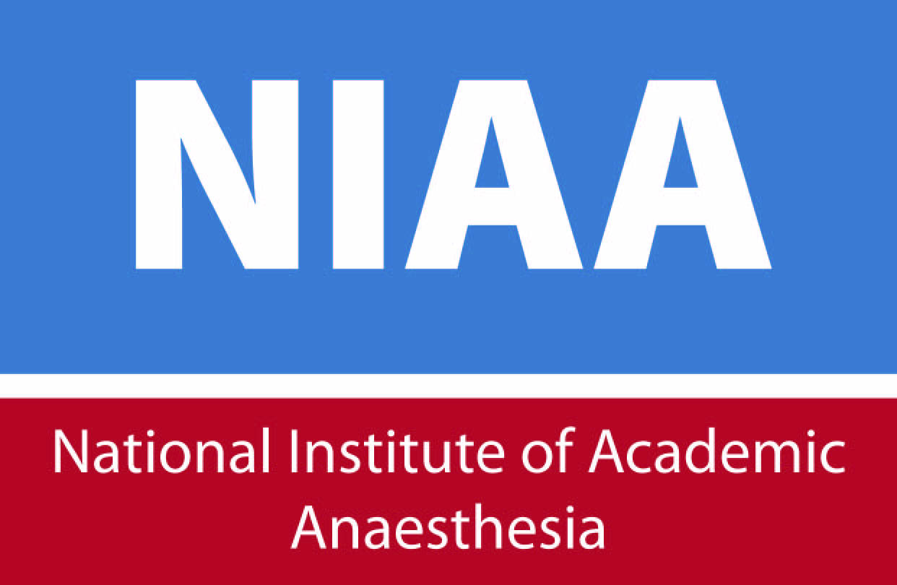

Guidance for ARCP panels for trainees undertaking research placements

This guidance applies to any trainee who at any time since their previous ARCP has been:
- in an Academic Clinical Fellowship or Clinical Lecturer post; or
- registered for MD(res), MPhil or PhD; or
- undertaking any training, trust grade or fellowship post with ≥25% WTE (usually 12 hours per week) dedicated to research; or
- out of programme for research (OOPR) or OOPE with ≥25% WTE research

Academic Progress Report

This form will be emailed by the RCoA Training department to all trainees who are approved for an OOP which involves research activity as stated above. It is also available on the ‘Trainee Resources’ page of the NIAA website for trainees who are undertaking in-programme research training.

Part A: Should be completed by the trainee and their supervisor(s) prior to ARCP
Part B: Should be assessed by an independent academic (i.e. not involved in the trainee’s supervision) – ideally in conjunction with the clinical ARCP panel, or if not available on the day of ARCP, in advance. It should be reviewed with Part A at the ARCP and signed off by the ARCP Panel Chair.

Identifying academic support for ARCPs

Please start by contacting the local NIHR Clinical Research Network lead for your region. The contact list can be found through this link:

http://www.nihr.ac.uk/nihr-in-your-area/local-clinical-research-networks.htm

Further support can be obtained via the National Institute for Academic Anaesthesia: please contact info@niaa.org.uk if you would like support.

Other helpful contacts

The NIAA Academic Training Coordinator is Dr Dan Martin and can be contacted for advice about the ARCP process and finding an academic representative. Contact info@niaa.org.uk.

The Academic Training Programme Director for London is Dr Ramani Moonesinghe, who can be contacted for general advice about the ARCP process for academic trainees, via info@niaa.org.uk.

The NIHR national Specialty Group Lead for Anaesthesia, Perioperative Medicine and Pain is Professor Mike Grocott. He can be contacted for further information about the NIHR Clinical Research Network and supporting academic trainees via info@niaa.org.uk.

http://www.niaa.org.uk/trainee-resources

